Full Paper Title
Name Surname¹, Name Surname², Name Surname^{3,*}
¹ Department of Chemical Engineering, Faculty of Engineering, Ubon Ratchathani University, Ubon Ratchathani 34190, Thailand
² Department of Chemical Engineering, Faculty of Engineering, Khon Kaen University, Khon Kaen 40002, Thailand
³ Environmental Protection Center (EPC), Ubon Ratchathani University, Ubon Ratchathani 34190, Thailand
* Corresponding author: tiche2026@ubu.ac.th

ABSTRACT
A concise and factual abstract is required, and an approximate maximum of 250 words should be observed. The abstract should briefly state the purpose of the research, the principal results, and the major conclusions. Since an abstract is often presented separately from the article, it must be able to stand alone. For this reason, references should be avoided; however, if essential, they should be cited using the Vancouver / Numbered style, e.g., [1]. In addition, non-standard or uncommon abbreviations should be avoided, but if essential, they must be defined at their first appearance in the abstract. The main body of the abstract should be written in Times New Roman, 10.5 pt, and single-spaced. The full paper must not exceed 8 pages, including references.
Keywords: Keyword 1; Keyword 2; Keyword 3; Keyword 4; Others (The keyword should be five of maximum)

1. INTRODUCTION
The introduction should provide a brief overview of the research topic, its importance, and the study’s context. Begin with the broad research area and narrow down to the specific problem or question. Explain the study's significance and its relevance to the field. Review key background information and previous research to set the foundation. State the research goals or hypotheses clearly, and briefly outline the paper's structure to guide the reader. Use Times New Roman font, 10.5 point, with single row spacing.
2. EXPERIMENTAL
The experimental section should detail the methods and procedures used in the study. Describe the data sources, materials, or subjects. Outline the experimental design, steps, and techniques used in the study. Mention any controls, variables, and measurements with clarity and precision. Include protocols or software and specify the statistical methods for data analysis. Use tables and figures to present detailed information and results effectively. Ensure the text is in Times New Roman font, 10.5 point, with single row spacing. In addition to the graphical and tabulated data, mathematical expressions can also be used to support the interpretation of the results. For example, the average plane between xx.xx-xx.xxº at 2θ were chosen for the calculation of AgNPs crystallite size using Debye Scherer's equation as shown in Eq. (1).
(1)
where D is crystallites size (nm), k is the Debye–Scherrer constant (0.89), λ is the X-ray wavelength, β is the line broadening in radian obtained from the full width at half maximum, θ is the Bragg angle or Peak position (radians).

3. RESULTS AND DISCUSSION
The results and discussion section of a research paper should present and interpret the findings of the study clearly and succinctly. Begin by summarizing the main results, using tables and figures where appropriate to enhance clarity and provide a visual representation of the data. Avoid repeating the information already presented in these visuals. Discuss the significance of the findings in the context of the research question, comparing them with previous studies and highlighting any new insights or unexpected outcomes. Address any limitation of the study and suggest potential implication for future research [1]. This section should integrate the results with the discussion to provide a comprehensive understanding of the study’s contributions. Ensure the text is in Times New Roman font, 10.5 point, with single row spacing.

Table 1 The table captions should be placed above the table as shown in this example.
The results and discussion section of a research paper should present and interpret the findings of the study clearly and succinctly. Begin by summarizing the main results, using tables and figures where appropriate to enhance clarity and provide a visual representation of the data [2]. Avoid repeating the information already presented in these visuals. Discuss the significance of the findings in the context of the research question, comparing them with previous studies and highlighting any new insights or unexpected outcomes. Address any limitation of the study and suggest potential implication for future research. This section should integrate the results with the discussion to provide a comprehensive understanding of the study’s contributions. The results and discussion section of a research paper should present and interpret the findings of the study clearly and succinctly. Begin by summarizing the main results, using tables and figures where appropriate to enhance clarity and provide a visual representation of the data. Avoid repeating the information already presented in these visuals. Begin by summarizing the main results, using tables and figures where appropriate to enhance clarity and provide a visual representation of the data. Avoid repeating the information already presented in these visuals. Begin by summarizing the main results, using tables and figures where appropriate to enhance clarity and provide a visual representation of the data. Avoid repeating the information already presented in these visuals. Discuss the significance of the findings in the context of the research question, comparing them with previous studies and highlighting any new insights or unexpected outcomes.
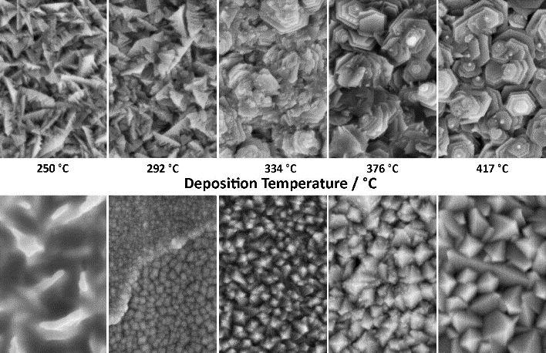
Figure 1 The figure captions should be centered below the figures as shown in this example.
The results and discussion section of a research paper should present and interpret the findings of the study clearly and succinctly. Begin by summarizing the main results, using tables and figures where appropriate to enhance clarity and provide a visual representation of the data [3]. Avoid repeating the information already presented in these visuals. Discuss the significance of the findings in the context of the research question, comparing them with previous studies and highlighting any new insights or unexpected outcomes. Ensure the text is in Times New Roman font, 10.5 point, with single row spacing.
4. CONCLUSION
The conclusion of a paper should summarize the key findings and their significance, providing a clear and concise wrap-up of the study. Begin by briefly restating the main research question or objectives and summarizing the principal results. Highlight the importance of these findings in the context of the field and their potential impact. Discuss any limitations encountered during the study and suggest directions for future research. Emphasize the overall contribution of the study to the existing body of knowledge and its practical or theoretical implications. Ensure the conclusion is clear, concise, and leaves the reader with a strong understanding of the study's importance and future potential. Ensure the text is in Times New Roman font, 10.5 point, with single row spacing.
ACKNOWLEDGMENTS
The acknowledgments section of a research paper should express gratitude to those who contributed to the study but did not meet the criteria for authorship. Begin by thanking funding sources, including grant numbers and sponsoring institutions, if applicable. Acknowledge the assistance of organizations who provided materials, technical support, or expertise that was crucial to the research. Mention any colleagues or mentors who offered significant guidance or feedback. If the research involved collaboration with researchers, briefly highlight their contributions.
REFERENCES
1. A. Hassani, A. Khataee, S. Karaca. Photocatalytic degradation of ciprofloxacin by synthesized TiO₂ nanoparticles on montmorillonite: Effect of operation parameters and artificial neural network modeling. Journal of Molecular Catalysis A: Chemical 2015; 409(2): 149-161.
2. L.L. Tayo, B.T. Doma. A review on the removal of pharmaceutical and personal care productsusing advanced oxidation processes. Journal of Advanced Oxidation Technologies 2018; 21: 102014.
3. E.M. Golet, I. Xifra. Environmental exposure assessment of fluoroquinolone antibacterial agents from sewage to soil. Environmental Science & Technology 2023; 37: 3243-3249.

